# CS 255 System Design Document Template

## UML Diagrams

### UML Use Case Diagram

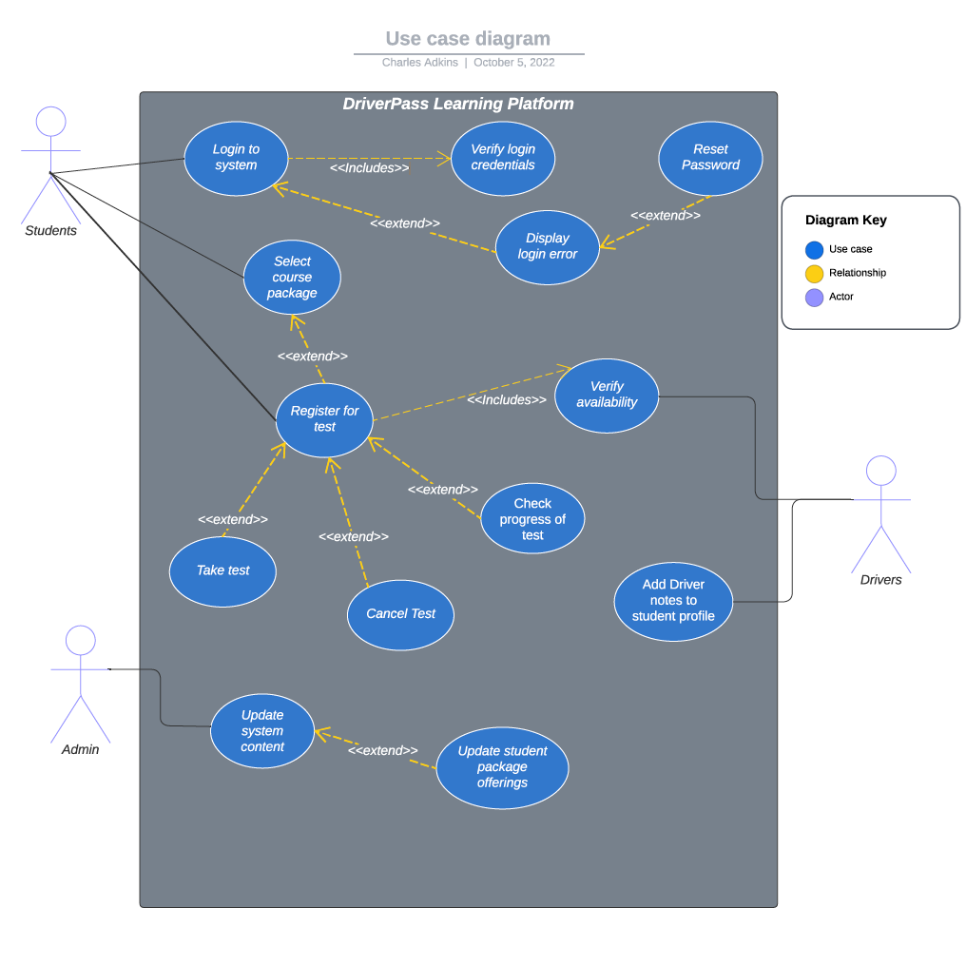

### UML Activity Diagrams – Diagram 1



**Figure 2: UML Activity diagram for Use Case – User login**

### UML Activity Diagrams – Diagram 2



**Figure 3: UML Activity diagram for Use Case – Administrator/IT updating platform content**

### UML Sequence Diagram



### Figure 4: UML Sequence Diagram – Uploading platform content

### UML Class Diagram

**

**Figure 5: UML Class Diagram – DriverPass Platform**

## Technical Requirements

**Technical Requirements for Business Requirements**

Once implemented, the system will allow for students to register their driver profile and reserve training time, select and pay for the appropriate training package, track their testing scores and history, submit notes/comments, view feedback from instructors, mitigate login/password issues, and contact administrators for system support.

The system will need to be accessible from both desktop and mobile devices. It will use a role-based access control framework, with Liam and Ian having global administrator privileges, the secretary with read/write permissions to update certain aspects for students, and students with read/write/delete permissions of their own data. It will also be cloud-based, as to avoid having to purchase and manage on-premise assets. Finally, the system will allow for exporting reports for operations analysis, minor changes to data such as user password resets, reservation adjustments, training package archiving and training material updates in accordance with DMV rules, policies and sample questions.

**Required Infrastructure**

**Software and Tools**

The platform can run on Windows and can be connected to a cloud-based database or storage account offered by a cloud solution provider, such as Azure. Azure is a cloud-based, subscription service that offers many options for the needs of various clients. The subscription handles resource groups, which hosts individual resource offerings that are used within the infrastructure of a clients’ project. For instance, virtual machines (VMs), networks, active directories, databases/storage accounts, and Web Apps are all resources that can be managed through a resource group, of which is then managed and billed through the subscription based upon the needs of a customer (Microsoft, 2022). More specifically, in addition to an Azure subscription, we will need an App Service subscription and App Service plan, which allows us to create the application and declare its’ capabilities, and for billing purposes. For our needs, the following will be required:

* Azure Subscription
* App Service Subscription
* App Service Plan
* Resource Group
* Resources
  + Web App
  + Active Directory

**App Service Plan**

The App Service Plan dictates a set of compute resources that available for the function of the Web App. The pricing tier selected for the App Service Plan determines the number of virtual machines (VMs) that the application will run on. The ‘Dedicated compute’ category covers Basic, Standard, Premium, PremiumV2, and PremiumV3 – the higher the tier, the more instances of VMs dedicated to the application. We will select the Premium tier, which allows for 30 instances. The plan offers auto-scaling, which will be helpful in the event that we need more computing resources due to network traffic changes. The charges incurred are reflective of the runtime for the VM instances and in the case of the Premium tier, that cost is $0.20/hr.

**Storage**

The storage account can be managed by an administrator through the Azure portal. The storage account will contain all of the Web App data and any other data that is valuable and relevant to the client. The pricing tier for the storage account is dependent on the size, storage function and retrieval latency. The App Service plan will come with 1 terabyte (TB) of storage for all applications managed by the plan, with 250 gigabytes (GB) allocated for each application within the single App Service Plan. If the application requires more storage space than allocated, more can be acquired and managed appropriately.

**Web App**

Font-end capabilities through Web Apps allows for the creation and deployment of web applications. The application will be hosted through a system generated domain name or can be attached to a currently owned domain name of the clients’ choice. The publishing aspect of the Web Apps functionality allows for application deployment, continuous integration, to be utilized to content/application updates, and more. Web Apps also allows for auto scaling, load balancing, auto-patching and high availability, all of which ensures that the platform provides reliable access to all users through a secure application. The DriverPass application will be developed using ASP.Net, PHP, Node. Js or Python – all of which are dependent on their respective capabilities, as it relates to the required functionalities for the platform.

**Administration, Active Directory and Security**

The Azure system also accommodates security, user access/permissions and monitoring and logging functionalities. All data hosted and stored within the Azure platform is encrypted, ensuring the privacy and protection of all system data. Administrators and IT personnel will be able to monitor the infrastructure of the application by utilizing the Monitor functionality of Azure, which grants visibility of performance, errors, traffic and other valuable metrics. In addition, various metrics and reports can be generated, exported and presented for the purposes of auditing, as well. The Active Directory functionality will allow for various users to utilize the Azure Portal, based upon their granted access/privileges.